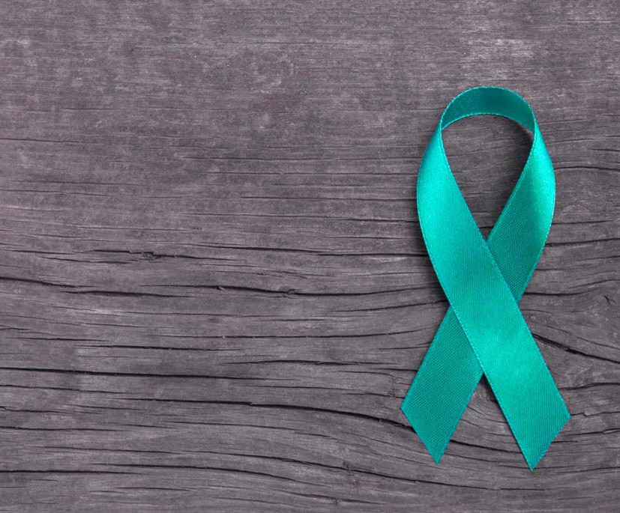
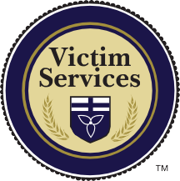





GUELPH AND WELLINGTON COUNTY, 2023

Support and Information Guide
For Survivors
of Sexual Violence

Disclaimer

For the purpose of this guide, the terms “victim” and “survivor” will be used interchangeably and will refer to anyone who has experienced sexual violence. We support a person’s right to choose how they wish to be identified. It is also important to note that this guide is not legal advice, and should be used for
information purposes only. Every effort has been made to provide precise information. However, your rights and a police officer’s responsibilities, depend on each specific situation. If at any time you are unsure of your rights, you can ask the officer in charge of your case. They are required by law to inform you. While we strive to provide and maintain accurate and up to date information, some information and resources in
this guide are subject to change. Should you have questions that are not answered within this guide, or you require additional clarification, please contact Victim Services Wellington.

This project has been made possible by the Ministry of the Attorney General Civil Remedies Grant Program

Table of Contents
What is Sexual Assault? 4
Definition Criminal Code Considerations Consent
Your Choices
Sexual Assault Investigations 6
Who Will Investigate and How? Charges/After Arrest
Intimate Partner Violence
Medical Care and Evidence Collection Youth and Sexual Assault
Court Process 10
Initial Process
Victim/Witness Assistance Program Trial/Duration/Sentencing
Victim Impact Statements Publication Ban/Media
Financial Assistance 11
Victim Quick Response Program+ Civil Law Suits
Resources for Support 12
Victim Services Wellington
Sexual Assault/Domestic Violence Care and Treatment Centre Women in Crisis/Rural Women’s Support Program
Compass Community Services Victim/Witness Assistance Program Child Witness Centre
University of Guelph Resources

What is Sexual Assault?

Definition
Sexual assault can be any form of non-consensual contact that feels sexual. It can include, but is not limited to, unwanted touching including kissing, hugging,
groping, attempted penetration, penetration, etc. It can happen to anyone regardless of age, gender, sex, socioeconomic status, culture, religion, race, etc. It can happen once, multiple times, or over a long period of time. It can be committed by anyone, including (but not limited to): friends, strangers, intimate partners, family members, persons of authority, etc.

Criminal Code Considerations
Sexual assault offences include (but are not limited to): sexual assault, sexual assault with a weapon, aggravated sexual assault, invitation to sexual touching, sexual exploitation, sexual interference, voyeurism, non-consensual distribution of intimate images, etc. There is no statute of limitations on sexual violence – you can report to police at any time, and if police have sufficient evidence and grounds to arrest, histor- ical sexual violence charges can be laid.

Consent to Sexual Activity
Consent can be defined as the voluntary agreement of a person to engage in sexual activity, where agreement is expressed both by words and/or by conduct/actions. You can express that you do not consent non-verbally by your actions, such as struggling or trying to stop/leave, pushing away, being stiff/still/frozen, etc. You can consent and then change your mind at any point during a sexual encounter. You can also agree to one kind of sexual activity but not other kinds. Consent must be given for each and every sexual act. Someone can be assaulted if they have engaged in sexual activity with the individual in the past. This does not mean that there is automatic consent for future sexual conduct.

You cannot give consent if:
- You are incapacitated by alcohol or drugs
- You feel threatened, intimidated, afraid, forced, frozen, etc.
- You are coerced (through intimidation, threats, misuse of authority, manipulating, bribing, etc)
- You have a disability that prevents you from making an informed choice.

If you are being assaulted, you can use reasonable force to defend yourself. Use the force that is necessary to protect yourself from the attacker and get away. Police will not charge you with assault if you were acting in self-defence or attempting to prevent the assault from happening. Compliance is not consent.
Consent, as defined above, also applies to anyone working in the sex trade. Anyone can be sexually assaulted at any time, by anyone. A sex trade worker can be assaulted by a client. Any sexual contact that is not consensually agreed upon is sexual assault.

Your Choices
After a Sexual Assault
  - You may choose to report to police and provide a statement along with evidence. This does not mean police will automatically lay charges (see “Sexual Assault In- vestigations” for more information). In Canada, there is no statute of limitations for sexual offences. You may report to police at any time, regardless of when the assault occurred.
  - It is a good choice to seek medical/emotional care and/or have a Sexual Assault Evidence Kit completed at the hospital. The hospital will not call police unless you ask them to. You do not have any obligation to seek police assistance (see Medical Care for more information).
  - You may choose not to take any action at all, however, it is recommended that you reach out for medical attention and support. Sexual assault charges are victim-led in most cases, which means you may make a report or provide a statement to police without proceeding with criminal charges. The perpetrator can be cautioned and spoken to, or they can be unaware of the report altogether. This may be different in cases where the perpetrator is your intimate partner, if you are a person under 16, or there is a significant risk to public safety. Please see “Intimate Partner Violence” and “Youth and Sexual Assault” for more informa- tion.
  - You can choose to take civil action against the perpetrator outside of the criminal justice system. In this case, you can represent yourself in court, however you should consult a lawyer for further instruction.
  - Crime Stoppers Guelph-Wellington is an anonymous reporting platform for all types of crimes. If you have witnessed a sexual assault, or have knowledge of an assault that has occurred, you can report this anonymously through Crime Stoppers. If you do decide to report through Crime Stoppers, you should keep
this private and not tell anyone you have made a report. It will be kept on file and you will be provided with a reference number once reported.

Sexual Assault Investigations

After Reporting
Who Will Investigate and How?
If police are called shortly after the assault, front line officers will arrive at the location, assess your physical and emotional condition, and request an ambulance or support if required. They will secure the scene and preserve/protect any physical evidence. They will conduct a brief interview to obtain basic details of the event and,
if possible, obtain a video/audio statement from you and any possible witnesses. They will advise you of your option to have Victim Services Wellington attend or ask if you would like to attend the Sexual Assault/Domestic Violence Care and Treatment Centre at the Guelph General Hospital. If required, police may need to interview others who were aware of the incident or who were possible witnesses. Police may also request a review of your phone and/or social media records. However this is voluntary and not required.
If the perpetrator is present and police identify reasonable grounds to lay charges, they will be arrested and transported to the station (if you choose to proceed with criminal charges). If the perpetrator is not present, police will advise you of next steps around charges and possible apprehension. Police will talk to you about preserving physical evidence by asking you not to bathe, clean the area where the crime hap- pened, wash the clothing worn during the assault, etc. In addition, they will offer
to help you get to the hospital to talk to a nurse about a Sexual Assault Evidence Kit (SAEK) (see Medical Care for more information about this process). If you choose to complete the SAEK, it can be stored at the hospital for a period of one year. Police may ask you to sign a medical release form so they are able to view the results of the
kit for the criminal court process (this step is completely voluntary – see Medical Care for more information).
Police or Victim Services Wellington will transport you to a place of safety and ensure you have adequate physical and emotional support. A detective in the Sexual Assault Unit is responsible for follow up and/or additional investigation. They will be in con- tact with you in the coming days.
If the report is historical, front line officers may take your initial statement and pro- vide information. The investigation will then be passed on to the Sexual Assault Unit for further investigation and follow up. If you have questions during this time about the status of your investigation, or if you have not heard from the Sexual Assault Unit for follow up, you have the right to contact them directly for clarification. If the sexual assault occurred in a different jurisdiction than the one in which you made your re- port, it will be forwarded to the division in that specific area for further investigation and follow up.

Charges/After Arrest
If you decide to pursue criminal charges, and police find reasonable and probable grounds to lay charges, the perpetrator will be arrested. Often, the accused will be released from custody after arrest. They will either be released from the station with conditions to abide by, or they will be held for a bail hearing in front of a Judge or Jus- tice of the Peace. These conditions will often include a ‘no contact order,’ which means that the accused cannot contact you directly or indirectly. They may not be able to attend your home, school, place of work, or anywhere you frequent, and there may be a restriction on how many meters the accused will need to stay away from you. If the accused breaches any of the conditions in their release order, they will be subject to
re-arrest and additional criminal charges may be laid.
Sometimes police will decide not to lay a charge – this does not mean that the sexual assault did not happen. It may mean that there is not enough evidence to prove a criminal charge in court. There may be other options available to you such as taking civil action, applying for a peace bond or restraining order, etc. In these cases, it is best to consult a lawyer. If the perpetrator is not apprehended, the case will be closed. However, your case can be reopened at any time pending any new evidence or infor- mation.

Intimate Partner Violence
Domestic or intimate partner violence is any use of physical or sexual force, actual or threatened, in a current or former intimate relationship. Intimate relationships include those between opposite and same sex partners, and can vary in duration and legal formality, which can include current and former dating, common law, and married couples.
There is a provincial mandate that directs all police in Ontario to proceed with criminal charges specifically related to domestic and intimate partner violence. If it is determined that a sexual assault within an intimate relationship has been committed, and reasonable grounds are established, police must proceed with charges regardless of the complainant’s wishes. However, police are extremely aware of the personal and private nature of sexual assault cases and evidence and, as such, will take into consid- eration your thoughts, concerns, and wishes regarding laying sexual-related charges. They will have an in-depth discussion with you regarding how to proceed. Only the Crown Attorney can withdraw a charge once laid, however they will only do so after careful consideration of the investigation, evidence, and case as a whole.

Medical Care
The Sexual Assault/Domestic Violence Care and Treatment Centre at the Guelph General Hospital is a team of specially trained individuals that include nurses, social workers, administrative persons and a trauma therapist. You may access the centre both immediately after a sexual assault incident through the emergency department or at a later time for follow up care. The centre will not report to police without consent from the victim. If the centre obtains information about sexual violence with a person under the age of consent, they have a duty to report to Family and Children’s Services. See “Youth and Sexual Assault” for information on age of consent.
If you are accessing medical supports immediately after a sexual assault, the intake is through the Emergency Department. If you disclose that you have been sexually as- saulted or have been injured as a result of intimate partner violence, you will be offered to have a sexual assault/domestic violence nurse paged to meet you within the hour. If you need to be seen by a physician as you have injuries, the nurse will arrive after your medical care has been provided. If you do not need to be seen by a physician, the nurse will take you upstairs to a more comfortable, private, medical setting.
If you are accessing supports for follow up care from the centre, you can call and make an appointment with the administrative assistant who will assess your needs and book you in with an appropriate person such as a nurse or counselor. If you have sought sup- port through another agency (ie. Victim Services Wellington), that agency may make a referral on your behalf and the centre will reach out to you to make an appointment.
Medical care can be provided in the form of, but not limited to: testing and treatment for STI’s (sexually transmitted infections), HIV (and preventative medications), Hepatitis, emergency contraceptives if pregnancy is a concern, and medical attention for other injuries (ie. bruising/soft tissue damage, cuts/scrapes/lacerations, etc). There can also be ongoing follow up care for the centre or referrals to specialists as well as follow up emotional support through counseling.
Participation in any of the above-mentioned practices or engagement with the program is completely voluntary and there is no age of consent to obtain medical care.
The Sexual Assault Evidence Kit (SAEK) is designed to collect and preserve possi- ble evidence that can be used in a criminal investigation. It is never required to have an SAEK collected. However medical care is always recommended. The SAEK is collected by sexual assault nurse examiners specifically trained in the collection and documenta- tion of evidence. There are 11 possible steps, all of which may be implemented depend- ing on what happened during the assault; the nurse will explain each step and together you will decide if you would like to proceed. These steps can include:

- Clothing collection
- Oral/fingernail/skin swabs
- Blood and urine samples
- Pubic hair combing
- Internal/external genital swabs
- Photographs and documentation of injuries

These steps can potentially collect physical evidence (the offender’s DNA) and this may aid in identifying the offender and/or confirming physical contact occurred. The details of the assault will also be documented on the SAEK forms.
If a SAEK is completed, it can be transferred directly to the police after collection at the request and with the signed consent of the victim. However, if the victim is un- decided about reporting the assault/pursuing charges, the SAEK may be stored at the Sexual Assault/Domestic Violence Care and Treatment Centre for a period of up to one year (it can be stored longer at the request of the victim). If you decide to provide the SAEK to police for investigation, it may be sent to the Centre for Forensic Sciences in Toronto for analysis. They will work to obtain a DNA profile of the offender(s).
However it is important to know that not all SAEKs will determine sufficient DNA to create a profile. DNA evidence is not necessary for a sexual assault conviction and DNA is only one piece of evidence in an investigation. Other types of evidence will also be considered.

Youth and Sexual Assault
The laws around sexual assault and youth pertain to ages of consent. A person is not able to give consent if:
- The survivor is 12/13 years old and the perpetrator is 2+ years older
- The survivor is 14/15 years old and the perpetrator is 5+ years older a
- The survivor is 16/17 years old and the person is in a position of trust or authority.
- If anyone is under the age of 18 and the sexual relationship is exploitative in nature, or the perpetrator is in a position of authority, trust, or dependence, there is never consent and the sexual activity is illegal.

Court Process

Initial Process
Once charges have been laid, the accused will be required to attend court for several appearances. During this time, the accused will receive disclosure (the contents of the police investigation), may retain a lawyer or utilize duty counsel, and will decide how to proceed moving forward (plead guilty or not guilty, set a trial date, schedule a preliminary hearing, etc). If the accused intends to plead not guilty, a date will be set for a trial, and a Crown Attorney will be assigned to the case. If a trial date is set, you may be required to testify in trial. If the accused pleads guilty, a date for sentencing will be set. In this case, you will not be required to testify as there is no trial. You will have an opportunity to complete a Victim Impact Statement (see “Victim Impact Statements”).
While the Crown Attorney considers your input in the case, they are not your lawyer; they are responsible for representing the community as a whole. As such, the information you share with them is not confidential. You do not require a lawyer, you are the victim in this case and the Crown Attorney is responsible for the conduct of the prosecution.

Victim/Witness Assistance Program
Your case will be referred to the Victim/Witness Assistance Program (VWAP). They are based in the court house and will assign you a worker to guide you through the court process. The role of your worker will be to inform you of the status of your crim- inal case, help you understand what to expect, provide you with copies of important documents, offer emotional support, coordinate with and provide victim input to
the Crown Attorney, assist in completing a Victim Impact Statement, advocate and coordinate supports and provide community referrals, and assist in trial/preliminary hearing preparation if you are required to testify.
If you are a youth, your case will be referred to the Child Witness Centre (police will make this referral on your behalf). Children and youth will receive an individu- alized assessment by their case worker who has knowledge related to child develop- ment, children’s mental health, and the judicial process. The worker will ensure that each youth and their caregiver(s) will receive services to meet their needs.

Trial/Sentencing
The length of the court case will vary depending on a number of factors. If the accused intends to plead guilty, the process will finish more quickly. Typically, court matters will be completed in 2.5-3 years maximum. If the court finds the accused

guilty, sentencing will be scheduled. There are different types of sentencing that vary depending on the severity of the crime(s). Your Victim/Witness Assistance Program worker will be able to provide you with additional information around sentencing and what to expect after trial.

Victim Impact Statements
A Victim Impact Statement is utilized in sentencing to explain the fears for safety and security, emotional, physical and financial impact that the crime has had on your life. It provides you with a voice in the court process to explain how the crime has affected you and the impact that it has had on various aspects of your life. The statement is voluntary and you have an opportunity to either read the statement aloud in court,
or written copies may be provided to the Crown Attorney, the prosecution and the judge. Your Victim/Witness Assistance Program worker can assist you in completing this statement, as well as advise you of the best time to submit it within the court proceedings.

Publication Ban/Media
After the first court date, the Crown Attorney may be able to apply for an order banning the publication of any evidence that may identify you, which may include your name. Section 486 of the Criminal Code advises that a Judge may prohibit the publication of identifying factors of both the victim(s) and the witness(es).

Financial Assistance

Victim Quick Response Program+
The Victim Quick Response Program+ (VQRP+) provides short-term financial support toward essential expenses for victims, their immediate family members and witnesses in the immediate aftermath of a violent crime to help reduce the impact of the crime, enhance safety, and meet immediate practical needs. The VQRP+ program is administered and accessed through Victim Services Wellington and the eligibility criteria and available supports can be discussed by connecting with the office staff (See “Resources” for contact information).
Eligible supports may include, but are not limited to, cell phones, home safety mea- sures, emergency accommodation, counseling, crime scene clean up, transportation, basic necessities etc.

Civil Law Suits
There is no longer a limitation period for civil law suits for crimes related to sexual assault (similar to criminal cases). In a civil case, the survivor often has more control over how the case proceeds. In a criminal case, the decisions are determined by the Crown Attorney, whereas in a civil case, the victim is responsible for making the de- cision on how the case moves forward in the court system. In a civil case, the survivor may choose to consult a lawyer, and if they choose to retain the lawyer they must pay for legal fees. There is also a possibility that if the survivor does not win the case, they could be responsible for paying a portion of the defendant’s legal fees.

Resources for Support

Victim Services Wellington
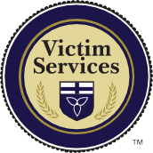
- Access to VQRP+ for emergency needs (safety, transportation, accommodation, counseling, etc). See “VQRP+” for additional information
- Safety planning and service coordination, short term case management
- Connections and referrals to community supports
- Assistance and support around police involvement,
as well as access to services without police involvement

Tel: (519) 824-1212 ext 7304
Email: victim@vswguelph.on.ca Web: www.vswguelph.on.ca

Sexual Assault/Domestic Violence Care and Treatment Centre (Guelph General Hospital)
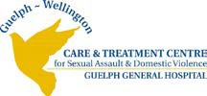
- Services available 24/7 through the Emergency Department
- Medical and emotional care
- Private, confidential, non-judgemental
- Trauma informed, victim centered
- Administration of a Sexual Assault Evidence Kit
- Short term crisis trauma counseling/therapy

- Referrals to other community supports
- Services are free

Tel: (519) 837-6440 ext 2728 (business hours) ext 2210 (after hours) Web: www.gghorg.ca

Guelph-Wellington Women in Crisis (G-WWIC)

- Individual and group counseling and support for women and gender diverse people, 16+ and their children who have/are currently experiencing any form of IPV.
Support to families and friends of survivors.
Services are free, interpreters are available.
Programs available:
- Marianne’s Place shelter.
- 24/7 Crisis Line – (519) 836-5710 or 1-800-265-7733
- Rural Women’s Support Program in Wellington County locations:
  - Erin: (519) 833-2301
  - Fergus: (519) 843-6834
  - Mount Forest: (519) 323-3638
  - Palmerston: (519) 343-5192 or 1-800-661-6041

Tel: (519) 836-1110 (business hours)
(519) 836-5710 or 1-800-265-7233 (24/7 crisis line and shelter) Email: adminrec@gwwomenincrisis.org
Web: www.gwwomenincrisis.org

Compass Community Services

- Individual and group counseling
- Publicly funded programs (Child and Youth Sexual Assault Team, Violence Against Women)
- Sliding scale for fees as well as geared to income programs
- Access to programs for all genders and sexes
- Locations in Guelph and Wellington County (Guelph, Fergus, Mount Forest)

Tel: (519) 824-2431 Web: www.compasscs.org

Victim/Witness Assistance Program

- Provide support throughout the duration of the court process.
- See “Victim/Witness Assistance Program” for additional information

Tel: (519) 837-6366

Child Witness Centre
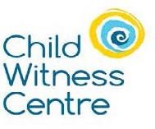
- Provide support throughout the duration of the court process.
- See “Victim/Witness Assistance Program”

Tel: (519) 744-0904 Web: www.childwitness.com

Services at the University of Guelph

Couple and Family Therapy Centre (Public)
Tel: (519) 824-4120 ext 56426 Web: www.cftcentre.uoguelph.ca

Counseling Services (For Students)
Tel: (519) 824-4120 ext 53244
Web: www.wellness.uoguelph.ca/counselling

Sexual Violence Support Coordinator (For Students)
Email: svinfo@uoguelph.ca
Web: www.uoguelph.ca/sexualviolence/panel/home

This guide was developed by Raquel Hall on behalf of Victim Services Wellington and Guelph Police Service. This guide is made possible by the Ministry of the Attorney General Civil Remedies Grant Program. The views expressed in this publica- tion are the views of the grant recipients and do not necessarily reflect those of the Province.





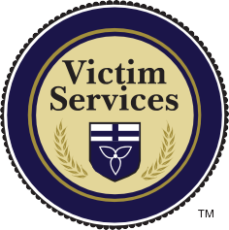
Notes
(519) 824-1212 ext 7304

Victim Services Wellington
Tel: (519) 824-1212 ext 7304
Email: victim@vswguelph.on.ca
Web: www.vswguelph.on.ca

Guelph Police Service
Tel: (519) 824-1212
Web: www.guelphpolice.ca

15 Wyndham Street South Guelph, Ontario N1H 4C6

