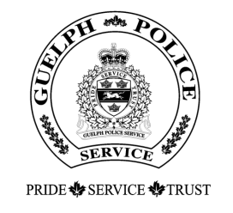
Guelph Police Services Board
For office use only:
Approved on __________
Amount: ______________

FINANCIAL REQUEST FORM

Community Account

Policy Statement and Intent:

The Community Account contains funds generated in accordance with Sections 132 and 133 of the Police Services Act. The Guelph Police Services Board provides funding to the Guelph Police Service and eligible community organizations for events or activities that address City of Guelph community safety and/or community wellness initiatives. Please complete ALL information requested, and read the Board’s Community Account policy at:
Community Account Policy (guelphpolice.ca)

Date: |  |  |  |  |  | Amount requested: |  |  |  |  | $
Date: |  |  |  |  |  | Payable to:
Name of Organization:
Name of Organization: | This is a not-for-profit organization. Yes No
Contact Person:
Mailing Address:
Telephone Number: |  |  |  |  | E-mail address:
Description of Event:
(Please provide information on your event and attach a flyer or pamphlet if available)
Number of Participants: |  |  |  | Total Cost of Event: |  |  |  |  |  | $
Other parties from whom you are seeking funding (if any):
Have you received Community Account funding in the past? Yes No
Which Year(s) & Amount received:
Indicate how the Guelph Police Services Board will be recognized at your event:

Continued on next page.

Please outline how this event/activity addresses City of Guelph safety and/or community wellness initiatives:

SIGNING AUTHORITY:
of the Organization |  | Name |  |  |  |  |  |  | Position
□ I have authority to sign for the organization.

If you have any questions, contact Leslie LaCelle, Executive Assistant, at (519) 824-1212 ext. 7213 or email board@guelphpolice.ca. Email your completed and signed form to board@guelphpolice.ca.

Note: All requests for funding must be approved by the Board, which meets the third Thursday of every month. The Executive Assistant will be in contact with you regarding your application soon after the meeting.

